 | 

Breakfast Chatter

The Weekly Bulletin of Rotary Club of Kathmandu Mid-Town
Dear all Rotarians of the Kathmandu Mid-Town Club I wish you all a peaceful and safe election day.

‘Success of any election hinges on participation. Voter participation ensures that a government is ‘of the people, by the people, and for the people’’ Rotarian and US Ambassador Peter W. Bodde in Republica Sunday, November 17, 2013
http://www.myrepublica.com/portal/index.php?action=news_details&news_id=64661

Weekly Meetings and Programmes:
Date | Speaker | Program/Topics of Presentation
8 November | DG Rtn. Dilendra Raj Shrestha | Club Assembly meeting conducted by the DG and regular meeting followed by  24th Charter Day Celebration
15 November | PDG & DRFC Rtn. Basu Dev Golyan | "Rotary New Global Grant"
22 November | 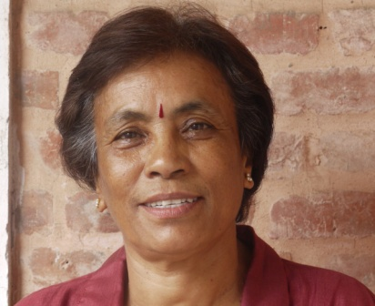 | Upcoming Guest Speaker Shyam Badan  She will speak about 'Fibre extraction and the future of fibre products in Nepal'  She is the founder and Director of Nepal Knot Craft Centre and among the 12 founders of Women’s Entrepreneurs Association of Nepal (WEAN)  From her CV:  In 1989 I started researching on indigenous raw materials and indigenous craft. Since then, I have identified 42 varieties of fibrous plants that can be used for furniture and other home accessories. Most of these fibers go to waste and many are nuisance to our environment. For example, water hyacinth, an invasive species which grows as pest clogging the lakes and swamps, can be used extensively for handicraft. Banana plants, which don’t degrade easily, can also be similarly used. I’ve used these materials, readily available and easily processed, to give employment to local women around Nepal. Natural Resource Development Center (NRDC) was established towards this goal.  We look forward to welcoming her as Guest Speaker

Club News
The DG Rtn. Dilendra Raj Shrestha informed that this was his mandatory visit to the 86 Rotary Clubs in Nepal and one in Bhutan. The visit is supposed to be completed by December but due to the holidays in between he expects to complete his visit by 2nd week of February as the visit to our club was his 40th visit.

His visit to the club would be a planning guide for the effective functioning of the club and he would be going thru the medical history and conduct a thorough medical checkup of the club. He informed that the club should set aside for 6 Club Assemblies, out of which two should be dedicated to the DG’s visit one 15 days ahead of the DG visit and one on DG’s visit.

He requested the Avenue Chairs to present reports and Chair of Avenue of Services presented their reports in the following order:

Club Administration Chair – Rtn. Dr. Isabella Khadka
Membership Chair – Since the Chair Rtn.Dr. Rabindra was not present so Rtn. Dr. Isabella presented the report on behalf of committee.

Public Relation Chair – Rtn. Ranjit Acharya
Service project Chair – Rtn. Rabi Karmacharya
Youth Service Chair – Rtn. Dr. Chandra Lekha Tuladhar
TRF Chair – PP Rtn. Komal Chitracar

DG Rtn. Dilendra Raj Shrestha presented comments and thanked all the Avenue Chairs for the excellent reports and informed the club that he found the RCKMT a HEALTHY club.

DG then handed over the meeting to President Saroj.

After the official meeting the Club celebrated the 24th Charter Day
Thanks to HE Peter Bodde who helped making the evening extra fun by donating the liquid entertainment! To Hotel de l'Annapurna for the amazing cake and to all participant and contributors for the raffle.

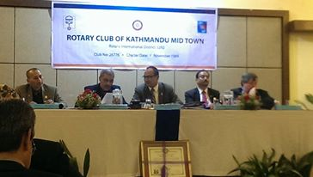 | 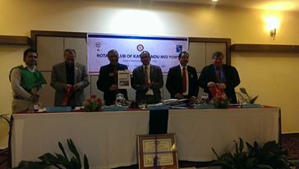

Induc Induction of New Member Rtn. Bhairaja Panday
Presi President Saroj requested Mentor of the club PP Rtn. William Ma for the induction ceremony of Rtn. Bhairaja Panday. PP Rtn. William conducted the induction ceremony and Rtn. KNS Thapa to formally introduced Rtn. Bhairaja Panday. DG pinned Rotary logo to new Member, VP Rtn. Peter presented literature and President Saroj presented Khada. The bouquet was presented to Spouse Neena by First Lady.
President welcomed newly inducted member Rtn. Bhairaja to Rotary family.

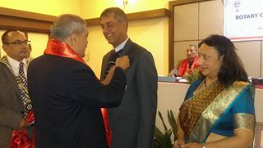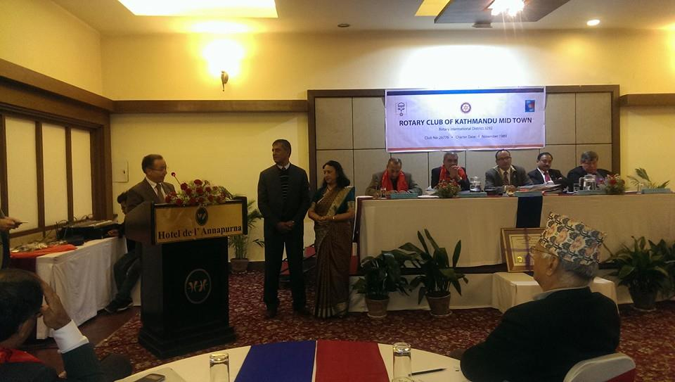

Happy Anniversary
A Hap A very Happy Anniversary to Rtn. Dr. Isabella and Dr. Narayan Khadka on 12 November.

Quotes of the day
If we value the pursuit of knowledge, we must be free to follow wherever that search may lead us. The free mind is not a barking dog, to be tethered on a ten-foot chain.
Adlai E. Stevenson Jr. (1900 - 1965), speech at the University of Wisconsin, Madison, October 8, 1952

Democracy is a process by which the people are free to choose the man who will get the blame.
Laurence J. Peter (1919 - 1988)

Mid-Town in the Press
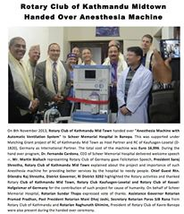 | Presid President Saroj’s gave long interview on Radio Shepherd 88.4 in Banepa during handed over program of the new Anaesthesia machine. The event was covered in several newspapers. Including Arthik Dainik and Himalaya Times  A picture was published in news paper Rtn. Rabi with the CNN Heroine Pushpa Basnyat.  Intervi President Saroj was also interviewed at Sagarmatha 102.4. the link has been distributed

A Thought for the Day:

Man's mind, once stretched by a new idea, never regains its original dimensions.
Oliver Wendell Holmes (1809-1894)

NB: Send any information/photos that may be of interest to the Club or Rotarians in general to

BC Editor: Anja M. Rasmussen, email: arasmussen@icimod.org

District : 3292 Web: www.rotarymidtown.org.np Club Id : 26776

Facebook: https://www.facebook.com/RotaryClubOfKathmanduMidtown

Rotary Kathandu Mid-Town Breakfast Chatter
 | Nov 18 (4 days ago)
  Anja Møller Rasmussen
to Ranjit, Paras, .KATH, Ajaya, AmarPanta, Ambika, AnandTuladhar, Arun, Asko, Bhairaja, Chandra, Colin, Dahal, Deepak, DevendraNath, Dr, Chandra, Rabindra, Giridhar, Giridhar, Gobinda, Gopal, IPDG, Isabella, Jo

Dear All,

Please enclosed find the Breakfast Chatter for November 8 to 15.

Please remember to mail me good stories, photos etc

Best regards.

Anja

Anja M. Rasmussen
Senior Manager. Knowledge Management and communication
International Centre for Integrated Mountain Development
GPO Box 3226, Khumaltar, Lalitpur, Kathmandu, Nepal.
Tel +977-1-5003222 Direct Line 5003310 Ext 155 Fax +977-1-5003277 Web www.icimod.org
Connect to ICIMOD:

